Resource 3 : Describing objects (pictures)

Expressions used to describe an object
Resource 3c | - Expressions describing shape:  round, oval, square, flat, long, diagonal, diamond-shaped, pear-shaped, heart-shaped, zigzag, elliptical, rectangular, triangular, circular  - Expressions describing size:  large, small, short, tiny, enormous, huge, average, pint-sized, microscopic, mid-sized  - Expressions describing dimensions:  hollow, cube, spherical, conical, cylindrical, concave (turning in), shapely, convex (turning out), bent, stretched  - Expressions describing directions:  up, down, left, right, north, south, east, west, above, below, over, under, between, beside, along, across, beneath  - Colour expressions:  red, blue, yellow, green, amber, azure, turquoise, jade, ashen, grey, brown, crimson, maroon, magenta, indigo, purple, violet, orange, pink, beige, silver, gold, bluish-green, greenish-red, purplish-yellow, inky-blue, icy blue, copper, rust  - Useful phrases:  a) This object is a…  b) It has…  c) It is used for…  d) It is made of…  e) It comprises…  f) It consists of…  g) The size of this object is…

Resource 3a | 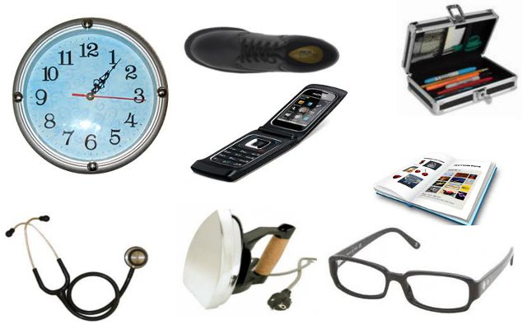

: Describing objects (descriptions)
Resource 3b | An open book: This is a rectangular object about the size of a shoe box. It is made of thin sheets of paper bound together. The inner sheets are encased in two covers, made of thick sheets. The object contains printed matter with margins on each side of the sheets. The object is used for gathering or displaying knowledge or information.  A pair of spectacles: This object consists of two pieces of glass that are held in place with a frame made of plastic, metal or wood. The two glass pieces are cut into a round, oval, square or rectangular shape, and held in a thin frame. The frame has two long sticks, about seven or eight centimetres long, which are bent at the ends to look like the letter “l.” This object is used to view things at a distance more clearly, or small objects and written matter that cannot be viewed by the naked eye.  A pencil box: It is a rectangular object, cuboid in shape, about 15 centimetres long, six centimetres wide and three centimetres high. It is made of plastic, metal or wood, and is used to store tools used for writing.  A mobile phone: This is a hand-held wireless instrument used to communicate with people at a distance. It has an in-built computer that allows the user to store the contact numbers of people they wish to speak to, and many other features that enable the user to communicate with other people. This object works on a battery and sometimes includes a torch. The advanced versions of this object can be used to watch TV, audio- or video- record events and sounds, and even allows the user to be visible to the listener.  A stethoscope: This is an instrument used by a doctor to listen to a person’s heartbeat. It consists of a rubber tube, about two feet in length, connected at one end to two metal tubes with earpieces. At the other end, the rubber tube is connected to a flat, round, metal object that resembles a medal.  Electric iron: An instrument used to remove creases from clothes, this object works on electricity. The object, about the size of a book, is conical in shape, and has a flat metal plate on one surface, which can be heated. The flat surface is attached to a metal or plastic casing that contains wires and other heating apparatus. The plastic case also has a non-heating plastic handle for people to hold it. The object may have a wire attached at one end to connect it to an electric point, or it may be wireless.  A shoe: This object is an article of clothing used by both men and women. It is made of a sturdy fabric. The object is about the size of a human foot, and is rectangular in shape, but rounded at the front and back. It is hollow and has a thick bottom called a “sole,” made of plastic or some other material that uses friction to keep it steady on the ground. The object has a soft inner lining for comfort. The fabric is stitched to the sole, and can be held in place by two laces that can be inserted into holes made in the front.

: Expressions used to describe an object
Resource 3c | - Expressions describing shape:  round, oval, square, flat, long, diagonal, diamond-shaped, pear-shaped, heart-shaped, zigzag, elliptical, rectangular, triangular, circular  - Expressions describing size:  large, small, short, tiny, enormous, huge, average, pint-sized, microscopic, mid-sized  - Expressions describing dimensions:  hollow, cube, spherical, conical, cylindrical, concave (turning in), shapely, convex (turning out), bent, stretched  - Expressions describing directions:  up, down, left, right, north, south, east, west, above, below, over, under, between, beside, along, across, beneath  - Colour expressions:  red, blue, yellow, green, amber, azure, turquoise, jade, ashen, grey, brown, crimson, maroon, magenta, indigo, purple, violet, orange, pink, beige, silver, gold, bluish-green, greenish-red, purplish-yellow, inky-blue, icy blue, copper, rust  - Useful phrases:  a) This object is a…  b) It has…  c) It is used for…  d) It is made of…  e) It comprises…  f) It consists of…  g) The size of this object is…

